CookieApp

Use-Case Specification: Register

Version 1.0

Revision History

|  |  |  |  |
| --- | --- | --- | --- |
| **Date** | **Version** | **Description** | **Author** |
| 16.10.14 | 1.0 | Initial Creation | Oliver Mahlke |
|  |  |  |  |
|  |  |  |  |
|  |  |  |  |

Table of Contents

1. Register 4

1.1 Brief Description 4

2. Flow of Events 4

2.1 Basic Flow 4

3. Special Requirements 7

3.1 Database 7

3.2 Mailserver 7

4. Postconditions 7

4.1 Registered 7

5. Extension Points 7

5.1 Login 7

1. Register
   1. Brief Description

The user enters his Credentials, to create an account.

1. Flow of Events
   1. Basic Flow

The user enters his name, his password and his email-address.

The user commits the data by pressing a button.

The system sends an error, if the credentials are incomplete, or if the name or the email is already taken.

The system sends an error, if the user hasn´t checked the “terms of agreement” box.

The system saves the Credentials.

The system sends an email to the address entered.

The user clicks the link in the email to finish registration.

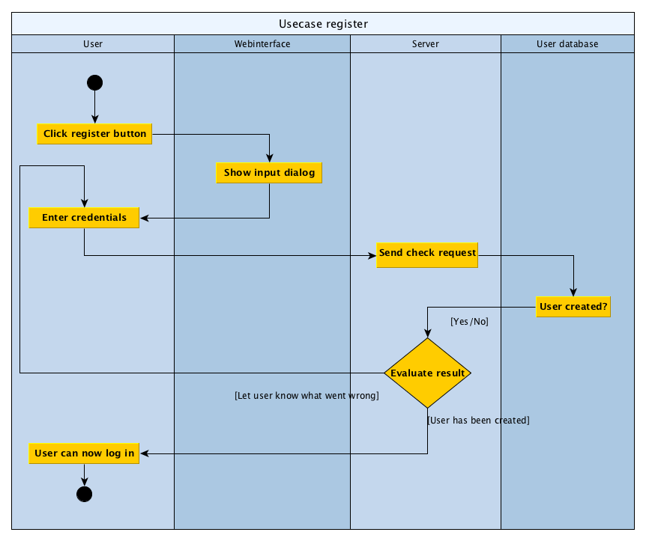

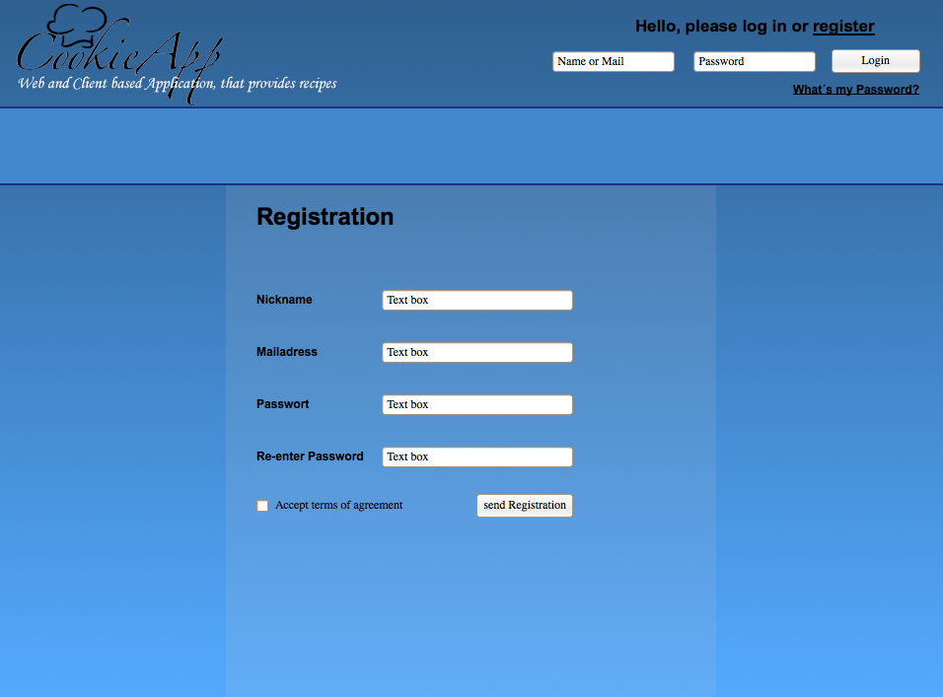

1. Special Requirements
   1. Database

The system needs a database to save the credentials.

3.2 Mailserver

The system needs a mailserver to send emails.

1. Postconditions
   1. Registered

The user is registered.

1. Extension Points
   1. Login

The user is now able to log in with his credentials.